Lab 5 - Battery Management
- Screenshot of your firebase RTDB receiving the ultrasonic sensor readouts.
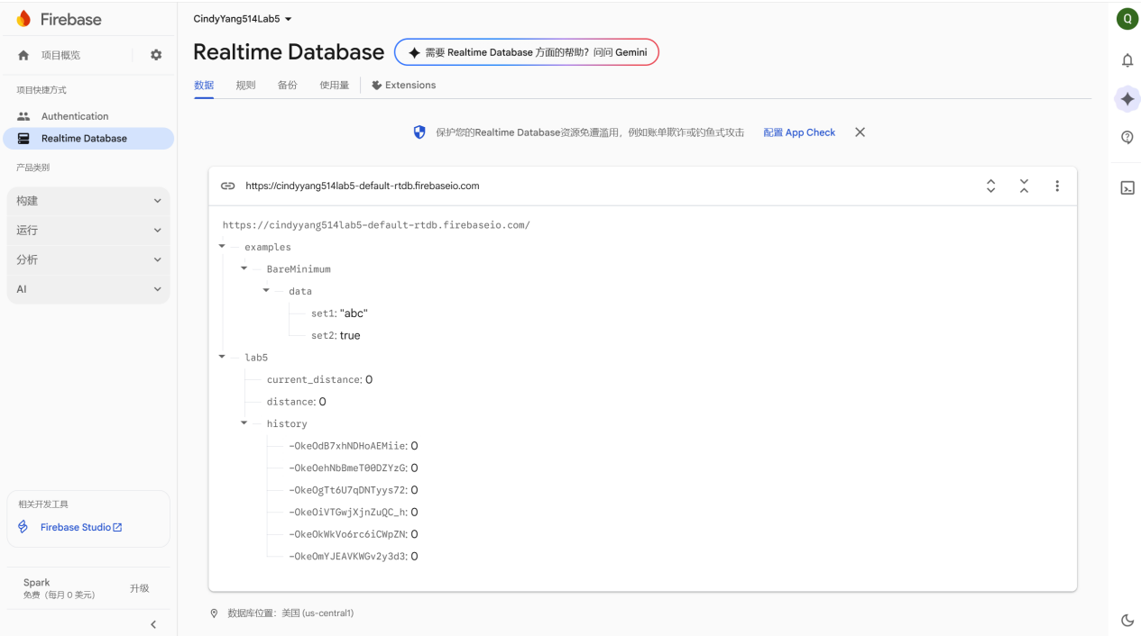

- Annotated screenshot of the plot on your power profiler app to show the power consumption in 5 different stages of ESP32S3's usage.
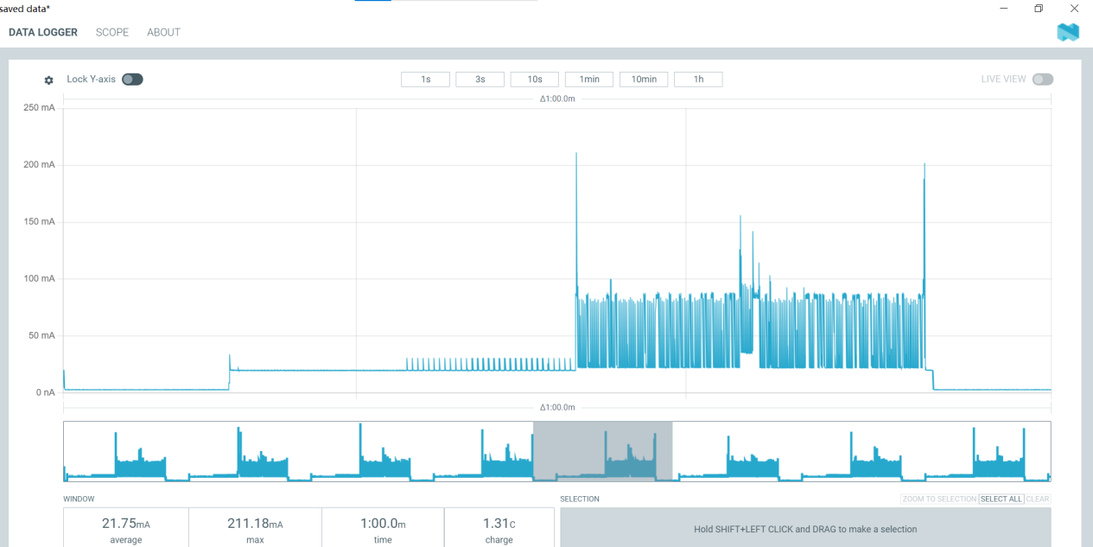
- Calculations of each stage's power consumption and estimated battery-lasting time, respectively.
- Deep sleep
Average Current: 2.85mA
Battery-lasting Time: 175.44 hours
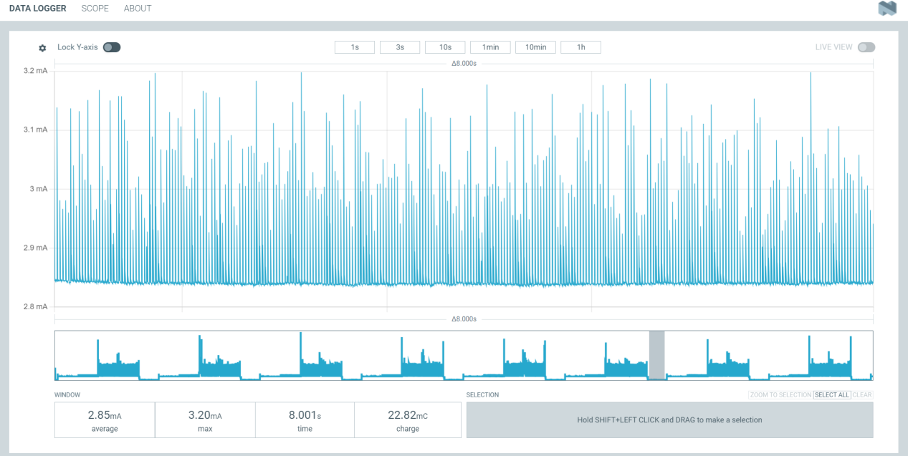
- Idle
Average Current: 19.82mA
Battery-lasting Time: 25.23 hours
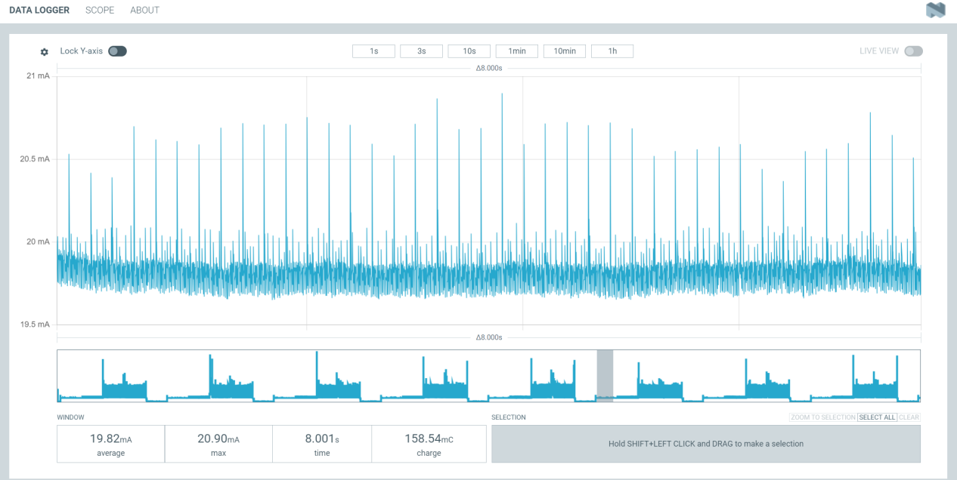
- Ultrasonic only
Average Current: 20.8mA
Battery-lasting Time: 24.04 hours
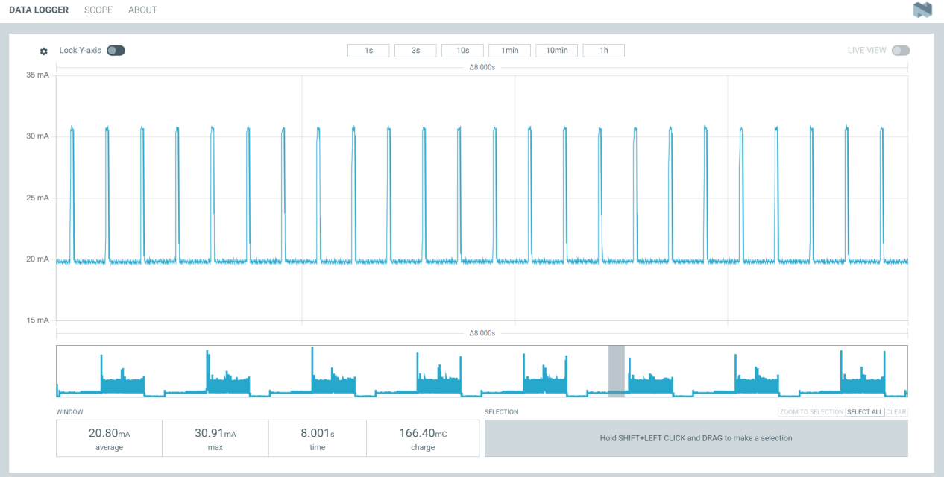
- Wifi only
Average Current: 34.23mA
Battery-lasting Time: 14.57 hours
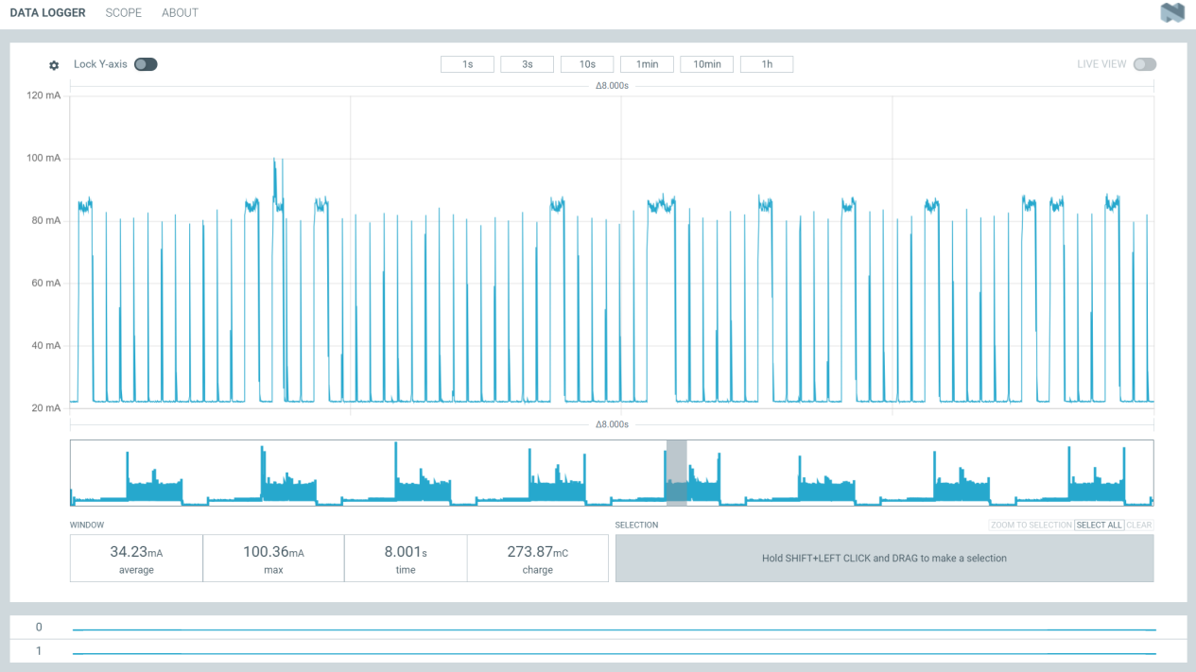

- Ultrasonic + Wifi + Sending data to Firebase
Average Current: 41.25mA
Battery-lasting Time: 12.12 hours
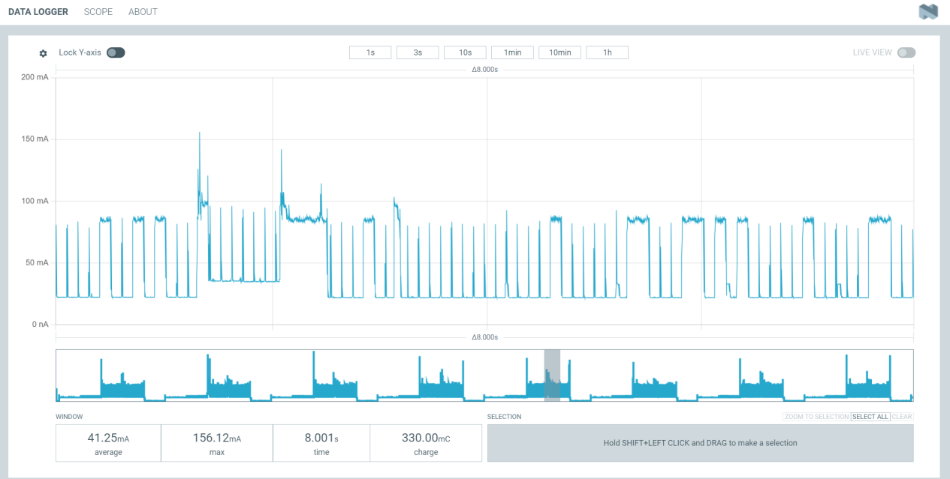

- Demonstrate the power consumption (W) during the data transmitting stage with different data transmitting frequencies. Plot the figure demonstrating the correlation between data transmitting frequency (Hz) and power (W).
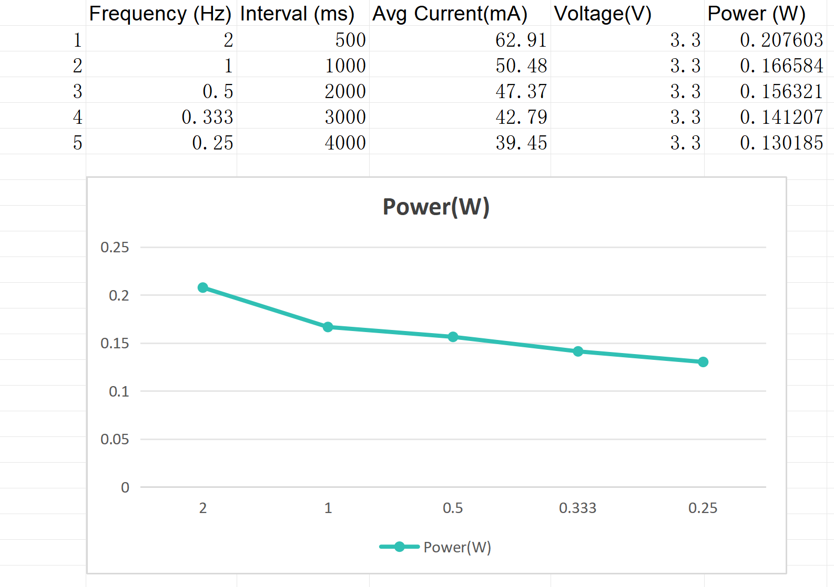
X-axis: Frequency (Hz) Y-axis: Power (W)

- Description of your own power-saving strategies/policies.
The ESP32 remains in deep sleep mode for most of the time, consuming only microamp-level current. Upon waking, it briefly powers the ultrasonic sensor to measure distance. If the measured distance is ≤ 50 cm, the system assumes an object or person is present and switches to a high-responsiveness mode, waking every 5 seconds. If the distance remains > 50 cm, indicating no activity, the ESP32 enters a low-duty cycle, sleeping for 30 seconds between measurements. Data is uploaded to Firebase only when the detection state changes, significantly reducing WiFi and transmission power consumption. After data upload, the ESP32 immediately re-enters deep sleep. This policy ensures that high-power WiFi and sensor usage only occur when meaningful environmental changes are detected.

- Annotated screenshots of the power consumption plot of your power-saving strategy's use case. The screenshot should at least include the deep-sleep stage and the working stage of your device.
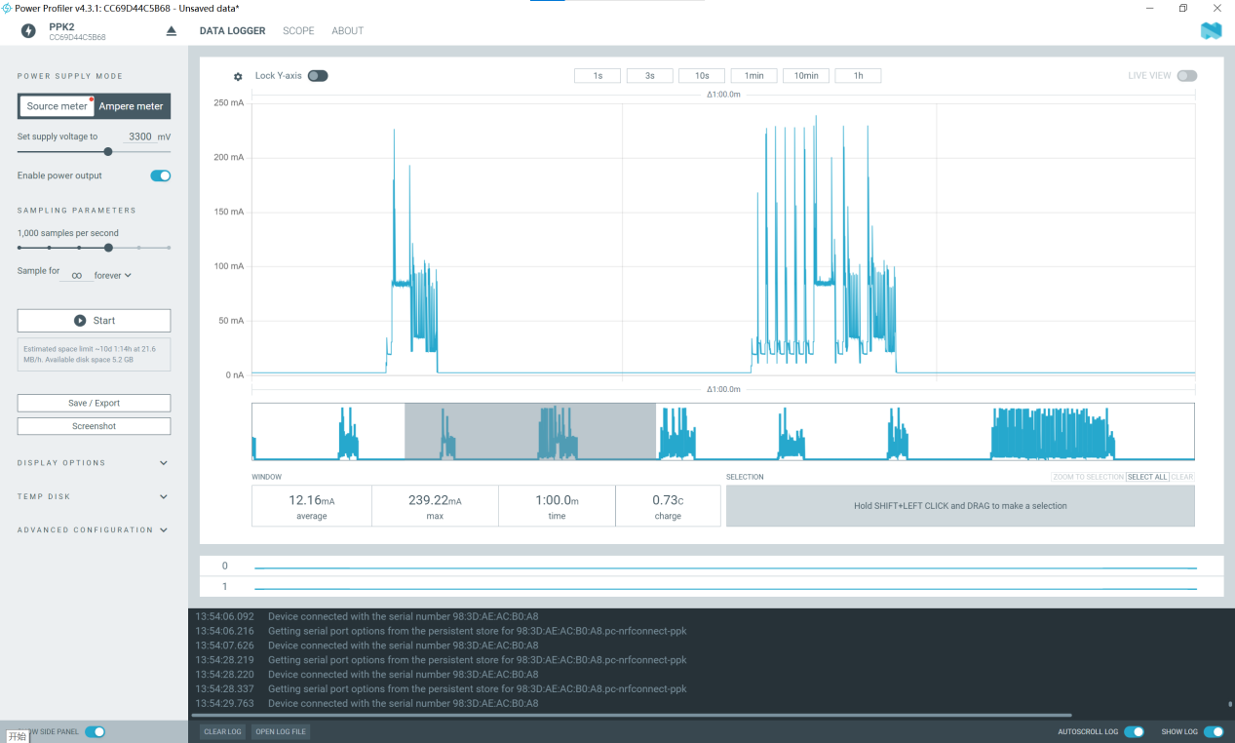

- Estimate your strategy's electrical consumption (mAh) in 24 hours under your simulated scenario. Prove that your strategy can make your device work for at least 24 hours with a 500mAh battery.
Total electrical consumption = 12.16 mA × 24 h = 291.84 mAh < 500mAh

- The link to your edited code with your power-saving strategy on GitHub. You can either create a new repo or push the updates to your existing repo for all labs (recommended).

